1) Setup a highly available ecs cluster with load balancer and dynamic port mapping.
NOTE:
Your cluster should maintain atleast 6 tasks at any point of time and should be highly availble across multiple AZ's.
Use the below image from deployment:
sabair0509/hiring-app:works
Pls refer the github repo
https://github.com/ALEEMUDDIN138/ECS-Project.git
Project Overview
This project demonstrates provisioning a highly available ECS Fargate cluster running a containerized web application with:
● Fargate tasks (serverless, no EC2 management)
● Application Load Balancer (ALB) for traffic distribution
● Dynamic port mapping for tasks
● Multi-AZ deployment for high availability
● CloudWatch logging for monitoring
● ALB → forwards traffic to tasks in multiple AZs
● ECS service maintains desired count of 6 tasks for HA
● Tasks registered with ALB target group (target type = IP)
________________________________________
Infrastructure Provisioned with Terraform
1️⃣ VPC and Networking
● VPC: 10.0.0.0/16
● Subnets: 3 public subnets (1 per AZ)
● Internet Gateway: Attached to VPC
● Route Table: Routes 0.0.0.0/0 to IGW
● Subnets associated with route table → public routing
________________________________________
2️⃣ Security Groups
● ALB Security Group:
○ Inbound: TCP 80 from anywhere (0.0.0.0/0)
○ Outbound: all traffic
● Task Security Group:
○ Inbound: all TCP from ALB SG
○ Outbound: all traffic
Ensures ALB can reach ECS tasks only.
________________________________________
3️⃣ Load Balancer (ALB)
● Type: Application Load Balancer (ALB)
● Subnets: All 3 public subnets (multi-AZ HA)
● Listener: Port 80 → forwards to target group
● Target Group:
○ Protocol: HTTP
○ Target type: IP (required for Fargate)
○ Health check: path /, protocol HTTP
ECS tasks automatically register with target group on dynamic port mapping.
________________________________________
4️⃣ ECS Cluster & Service
● Cluster: ha-ecs-cluster
● Service: Fargate, desired count = 6
● Network mode: awsvpc (required for Fargate)
● Subnets: 3 public subnets
● Public IP: Assigned to each task
● Load balancer integration: forwards traffic to container port 80
Deployment strategy: minimum_healthy_percent=50, maximum_percent=200 for zero downtime deployments.
________________________________________
5️⃣ ECS Task Definition
● CPU: 512
● Memory: 1024
● Execution Role: ecs_exec_role (pull images, write logs)
● Task Role: ecs_task_role (optional for custom permissions)
● Container:
○ Name: hiring-app
○ Image: sabair0509/hiring-app:works (replace with working image if needed)
○ Port Mapping: containerPort = hostPort = 80
○ Log Configuration: AWS CloudWatch Logs /ecs/ha-ecs-cluster
Important: In Fargate, hostPort must match containerPort (or omit hostPort).
________________________________________
6️⃣ IAM Roles
● Execution Role: AmazonECSTaskExecutionRolePolicy
● Task Role: Custom role for your app (if needed)
● Policy Attachments: CloudWatch logs writing, image pulling
________________________________________
7️⃣ CloudWatch Logging
● Log group: /ecs/ha-ecs-cluster
● Stream prefix: ecs
● Logs from containers are sent automatically.
________________________________________
8️⃣ Optional Autoscaling
● Service autoscaling configured:
○ Min capacity = 6
○ Max capacity = 12
● Can scale based on CPU / memory metrics (can be added if needed)
________________________________________
Terraform Outputs
● alb_dns → URL of Application Load Balancer
● ecs_cluster → ECS cluster name
Once deployed, open http://<alb_dns> to access the app (requires a working container image).
________________________________________
Deployment Steps (Terraform)
1. Clone project folder with main.tf
2. Initialize Terraform:
terraform init
terraform validate
terraform plan
terraform apply -auto-approve
terraform output alb_dns

Testing Locally (Optional)
To ensure your Docker image works before deploying:
docker pull sabair0509/hiring-app:works
docker run -d -p 8080:80 sabair0509/hiring-app:works
curl http://localhost:8080
If the container doesn’t start, rebuild it with a proper CMD / web server start command.
Key Learnings
1. Fargate + awsvpc mode requires hostPort = containerPort.
2. Target type = IP for ALB → Fargate integration.
3. Public subnets + assign_public_ip required for ALB to reach tasks.
4. CloudWatch logs are essential for debugging ECS containers.
5. Health checks on ALB target group are critical — wrong path causes 503.
6. Terraform allows fully automated, reproducible ECS + ALB deployment.
use below command to test output table:
# Describe service counts (desired, running, pending)
aws ecs describe-services \
--cluster ha-ecs-cluster \
--services ha-ecs-cluster-svc \
--query "services[0].{Desired:desiredCount,Running:runningCount,Pending:pendingCount}" \
--output table
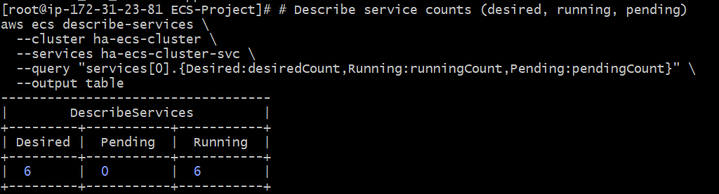
Output while testing on machine
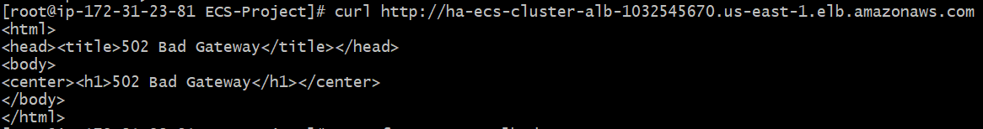
Output while testing on Browser
